**Question 10.27, Astro Assignment 1**

**Effy Oommen John**

**2018B5A40945P**

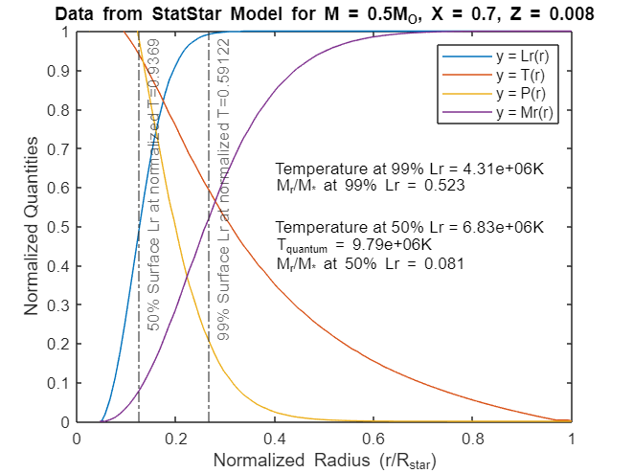

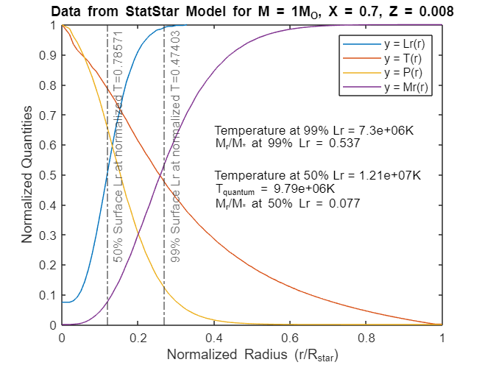

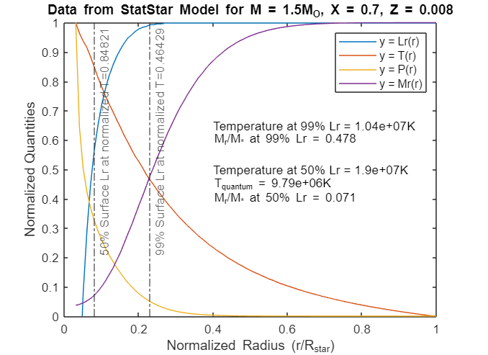

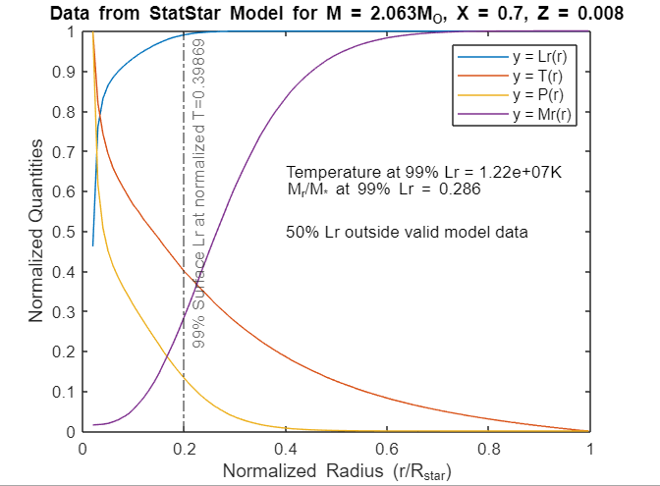

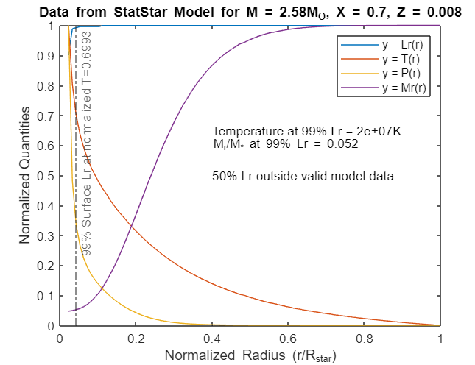

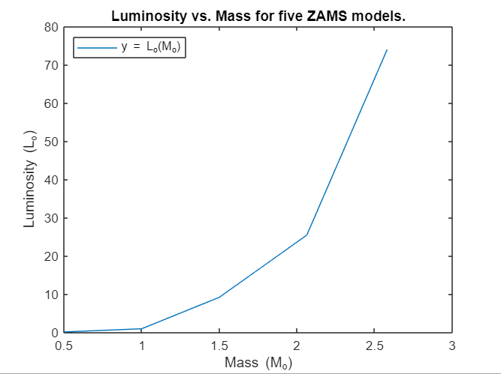

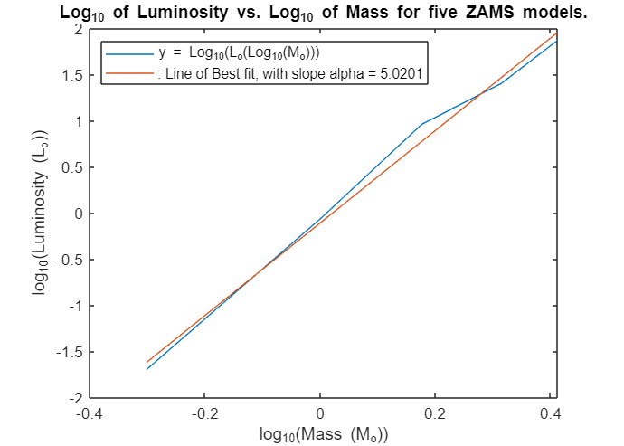

The above graphs are my solution for 10.27. For part b, yes, my calculated values of T at 50% of Lr match the rough estimate calculations to a reasonable degree of error. My MATLAB code that I used for the question, and all other related files, including the models generated will be available at the link below:

<https://github.com/EffyJohn/AstronomyCourse>